Synergy of the Elements (A Side-Scrolling Action Game)

Requirements Document

Mathew Doty

Scope

The scope will include the requirements needed to make a functional level for a side-scrolling video game using the Unity Engine. The level should include a playable character with the ability to run, jump and attack with the goal to fight enemies on the way through the level and finish by defeating a boss enemy at the end.

Goals

* For this demo, the application may simply start at the beginning of the level. (May include a GUI for starting and restarting the level at the end.)
* The player character must be able to run, jump, attack, guard and dodge roll. The dodge roll should include temporary invulnerability.
* The player’s main attack should be a group of multiple rapid attacks followed by a finishing move to knock the enemy away.
* The player should be able to use singular attacks in the air.
* The player should also execute three kinds of special attacks, a ranged ball, a dashing air attack and a shockwave to push away surrounding enemies.
* The level should include platforms for the player to traverse the environment up and down as they progress. (Possibly implement a wall jump and ledge grab to help with platforming.)
* The GUI should include at least a health bar for the player character and an energy meter for special attacks. The energy meter should lower with each special attack and slowly recharge overtime.
* The level should include checkpoints for the player to respawn and gain health, should they lose all their health. No extra lives necessary.
* The level should include three kinds of enemies, two grounded enemies with different weapons and movements and one small, floating orb-like enemy.
* The level should end with a large, slow boss with wide-ranged but telegraphed attacks for the player to dodge. The boss should have a large amount of health but may have methods to be knocked down for an easier chance to apply multiple attacks.
* The level should end after the player defeats the end boss.

Functional Requirements

Use Cases

1. Starting Phase
   1. Steps
      1. When game starts, player character is placed on a the beginning of the level. (Finished game would present introduction of some sort.)
      2. Give a second of time before the player can control the player character
2. General Movement
   1. Inputs (Buttons can be changed)
      1. 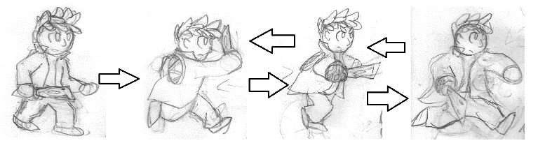When the player holds an arrow key left or right, the player character will run left and right along the ground. The player character will skid slightly for a second when turning in the other direction or stopping. They will continue their running animation but will not move if they push against a wall.
      2. 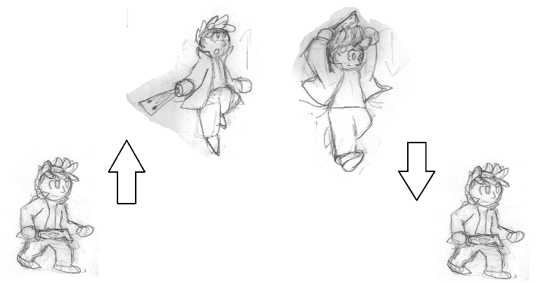When the player presses the spacebar, the player character will jump in the air. The length of time the character jumps depends on the length of time the button is held, from half the character’s height in a half second to three times the character’s height in two seconds. The character will fall at about the same rate of the initial jump, whether they fall off a ledge or after jumping. The player should be able to steer the character with the arrow keys while in the air.
      3. 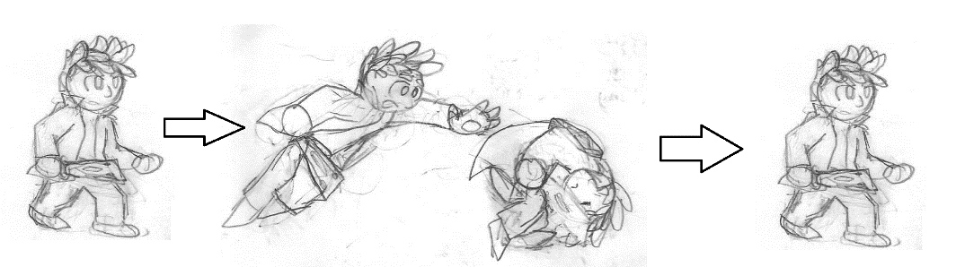When the player presses the C button while moving, the player character will perform a quick roll on the ground, during which they will be invulnerable to most enemy attacks for a moment before getting up.
3. Attacking Enemies
   1. Inputs
      1. When the player presses the X button, the character performs a lunging punch with a hitbox on their fist. When the hitbox connects with an enemy, the enemy will be stunned, pushed slightly back and lose health.
      2. When the player presses the X button while in the air, the character will attack with a single downward slash in front of them, attacking grounded enemies normally and knocking down enemies in the air.
      3. When the player rapidly presses the X button after the first attack, the character would continuously attack with a flurry of slashes with a hitbox on the sword. The enemy will remained stunned, being slowly pushed back and losing health until it is outside the hitbox.
      4. A drawing of a person pointing to a red point

         Description automatically generatedA drawing of a person

         Description automatically generated with medium confidenceWhen the player holds down the X button after any other attack, the character uses a kick to knock back the enemy and have them lose a chunk of their health.
4. Enemy Actions
   1. Prerequisites
      1. The player character and enemy must be in the same area, somewhat nearby each other. (There may be an area marker that triggers the enemy to notice and seek the player character.)
      2. Otherwise, the enemy will remain idle until this condition is met.
   2. Actions
      1. Upon noticing the player character, the enemy would approach the player, taking on different behavior depending on the enemy type. All enemies will typically be vulnerable after doing an attack.
      2. The sword enemy traditionally approaches the player and alternates between swinging at the player and blocking their attacks. This enemy can attack with regular ground swings and a rising uppercut slash. The regular ground swings should push the player back slightly while the uppercut should knock down the player.
      3. The claw enemy will rush the player at a fast pace and use more hit and run based tactics. They can swipe at the player several times on the ground or jump in the air then dive at the player diagonally. They will usually try to jump back after an attack and cannot block. All attacks should knock the player back considerably.
      4. The orb enemy will usually float above and diagonally away from the player. They will stop and fire a laser in a straight direction towards the player before moving again for another period of time. The blast should knock the player back. If the player attacks the orb, they will be knocked down to the ground and vulnerable to attack until they are knocked away or left alone.
      5. After reducing any enemy’s health to zero, they will disappear.
5. Blocking
   1. Inputs
      1. When the player holds down the C button while stationary, the character will block attacks and take less damage and knockback from an enemy’s attacks.
      2. While blocking, the player should have a protective box in front of the player so they are only protected from attacks in front of them. If an enemy hits from behind, they will react as though they weren’t blocking.
6. Special Attacks
   1. Prerequisites
      1. Energy meter must be full (Will be indicated in GUI)
   2. Inputs
      1. All special attacks require a full energy meter and will take away a certain portion of the meter to indicate a recharge. The energy meter will take about 10 seconds to charge from empty to full. All attacks can be used on the ground or in the air.
      2. When the player presses the V button while stationary or pressing left or right, the character will throw a ball of electricity horizontally. If the ball hits an enemy, it will cause them to be knocked back and take damage. This attack will take 50% of the meter.
      3. When the player presses the V button while pressing the up key, the character will fly in a straight line for about three seconds. The player can use the arrow keys to control the trajectory of where they fly. Running into an enemy will knock them out of the way and cause light damage to the enemy. This attack will take 25% of the meter but should not be able to be used again until they return to the ground.
      4. When the player presses the V button while pressing the down key, the character will unleash an electric blast that surrounds them. This will cause moderate damage to enemies and knock them away significantly. This attack will take 100% of the meter.
7. Checkpoint
   1. When the player reaches a visible checkpoint and touches it, the character’s health bar should fill back up to full capacity, undoing previous damage from other enemies.
   2. There should not be any enemies near a checkpoint, nor should any be able to chase the player to the checkpoint.
   3. If the player loses all of their health, the player will return to the last checkpoint they touched with all progress saved up to their last interaction.
8. Boss
   1. Prerequisite
      1. Reach a room in the level to trigger the boss
   2. Actions
      1. Once the player enters the room, the player will be put into position and paused until the boss readies into a fighting position.
      2. Boss will attack with large, but predictable attacks at the player, either telegraphed swings or falling rocks.
      3. The boss will have a much larger health bar than most enemies with the player needing to climb up a ledge and attack the boss where the main body is.

|  |  |
| --- | --- |
| Player Input | |
| -Applies movement to player character depending on the button pressed  -Activates pause menu when Enter key is pressed | -Player Character  -Pause |

|  |  |
| --- | --- |
| Player Hurtbox | |
| -Indicates the collision of the player character sprite, allowing the player to move around the environment and get hit by an enemy hitbox, lowering the player health. | -Player Character  -Enemy Hitbox  -Player Health |

|  |  |
| --- | --- |
| Enemy | |
| -Attacks the player when entering within a range close to the enemy  -Sword/Claws has hurtbox and body has hitbox  -Disappears when defeated | -Enemy Hitbox  -Enemy Hurtbox  -Enemy Health  -Environment  -Room |

CRC Cards

|  |  |
| --- | --- |
| Player Character | |
| -A figure to take the player’s inputs as an avatar to move and fight through the level, including running, dodging, jumping and attacking.  -Performs animations to indicate inputs from the player and interactions with enemies. | -Player Input  -Player Hurtbox  -Player Hitbox  -Checkpoint  -Environment  -Room |

|  |  |
| --- | --- |
| HUD | |
| -Displays health of player and energy meter at all times during gameplay.  -(Displays progress in level?) | -Player Health  -Energy Meter  -(Checkpoint)  -(Room) |

|  |  |
| --- | --- |
| Player Health | |
| -Begins at full when starting a level.  -Goes down after player hurtbox contacts enemy hitbox  -Health is restored to full when passing a checkpoint  -When health reaches 0, player character returns to last checkpoint | -Player Character  -Player Hurtbox  -Checkpoint  -HUD |

|  |  |
| --- | --- |
| Enemy Health | |
| -Displays as meter above enemy when hit  -Begins at full and goes down when enemy hurtbox contacts player hitbox  -When health reaches 0, enemy falls over and despawns | -Enemy  -Enemy Hurtbox |

|  |  |
| --- | --- |
| Checkpoint | |
| -Allows player to respawn when they lose all their health  -Restores player health when touched | -Player Health  -Player Character  -Room |

|  |  |
| --- | --- |
| Pause | |
| -Halts game when pressing pause button, stopping all movement from player, enemies and environment. | -Player Input |

|  |  |
| --- | --- |
| Boss | |
| -Activates upon entering boss room.  -Remains stationary and attacks with slow limbs and projectiles. | -Room  -Enemy Health  -Enemy Hitbox  -Enemy Hurtbox  -End Screen |

|  |  |
| --- | --- |
| Energy Meter | |
| -When full, the player can use one of three special moves.  -When used, the meter will fill incrementally overtime until it is full again. | -Player Character  -HUD |

|  |  |
| --- | --- |
| End Screen | |
| -When the boss’s health is brought to zero and indicates their defeat, the game will indicate that the level is complete. | -Boss |

|  |  |
| --- | --- |
| Environment | |
| -A floor and series of ledges and platforms that the Player and Enemies run on. | -Room  -Player Character  -Enemy  -(HUD) |

|  |  |
| --- | --- |
| Room | |
| -Sections of the environment for waves of enemies to spawn and detect the player (begin functioning) when they enter | -Environment  -Enemies  -Boss  -Player Character  -(HUD)  -Checkpoint |

|  |  |
| --- | --- |
| Enemy Hurtbox | |
| -Indicates the collision of the enemy sprite with the environment and player hitbox, which will lower their health. | -Player Hitbox  -Player Health  -Enemy  -Boss |

|  |  |
| --- | --- |
| Enemy Hitbox | |
| -Indicates collision of enemy attack on a player hitbox  -Reduces health of player when colliding | -Player Hurtbox  -Player Health  -Enemy  -Boss |

|  |  |
| --- | --- |
| Player Hitbox | |
| -Appears when player attacks  -Reduces health of enemies when colliding with enemy hurtbox | -Enemy Hurtbox  -Enemy Health  -Player Character |